Contents

I. General Information 1

A. System Overview 1

B. Benefits of the system 1

C. Project References 2

II. System Summary 3

A. Basic workflow 3

B. User Access Levels 3

III. Getting Started 4

A. Logging on to the system 4

B. User account management 4

C. Exit the system 6

IV. Using the system 7

A. Administrator 7

1. Main menu 7

2. Patient Manager 7

3. Package Manager 8

4. User Manager 9

5. Test Manager 9

6. Test Methods Manager 10

7. Normal Values Manager 11

8. Turnaround Time 12

B. For Encoders 14

1. Main menu 14

2. Barcoding 15

C. For Medical Technologists 16

1. Main menu 16

2. Viewing the results 19

3. Rerun the test 19

V. Troubleshooting 19

A. Software Troubleshooting 19

B. Network Troubleshooting 20

C. Important Notes 20

# General Information

## System Overview

The TCM Laboratory Information System is an application software for medical laboratory that helps to manage laboratory orders from inputting, processing, and storing data of medical processes and tests generated by the machine under hematology, chemistry, immunology and microbiology sectors.

## Benefits of the system

The main purpose of the system is to improve laboratory efficiency, accuracy and management by reducing manual operations. The system performs a range of functionalities including:

*Record Keeping*

The TCM LIS is commonly used in collection of data to keep accurate records of each laboratory order. Detailed information can be recorded when the order arrives in the laboratory, this normally includes the patient information and tests to perform. It also includes information of medical technologists working on the tests and which parts of the workflow it has passed through. Using the system allows easy retrieval of data and patient results history.

*Workflow Management*

The system can be used to streamline the laboratory workflow, from encoding to assigning tasks where a sample needs to be passed to for its next step in the workflow. It can then be used to allow the users to choose a machine or instrument based on the test to perform.

*Reporting*

The LIS is an essential tool to maintain accurate reporting. The system can generate report for each section in the laboratory based on performed tests. Additionally, the system displays a report for the amount of time taken to complete a process or fulfill a request.

## Project References

References that were used in preparation of this document in order of importance to the end user:

[*https://www.limswiki.org/index.php/Laboratory_information_system*](https://www.limswiki.org/index.php/Laboratory_information_system)

[*https://study.com/academy/lesson/laboratory-information-system-lis-definition-functions.html*](https://study.com/academy/lesson/laboratory-information-system-lis-definition-functions.html)

[*https://searchhealthit.techtarget.com/definition/laboratory-information-system*](https://searchhealthit.techtarget.com/definition/laboratory-information-system)

*http://medprojects.com/2017/what-are-the-uses-and-benefits-of-a-laboratory-information-system*

*https://drdollah.com/laboratory-information-system-lis*

# System Summary

## Basic workflow

Users logged in to the system based on user access level. Using the system, a laboratory order is managed and moved through a typical laboratory operation as shown below:

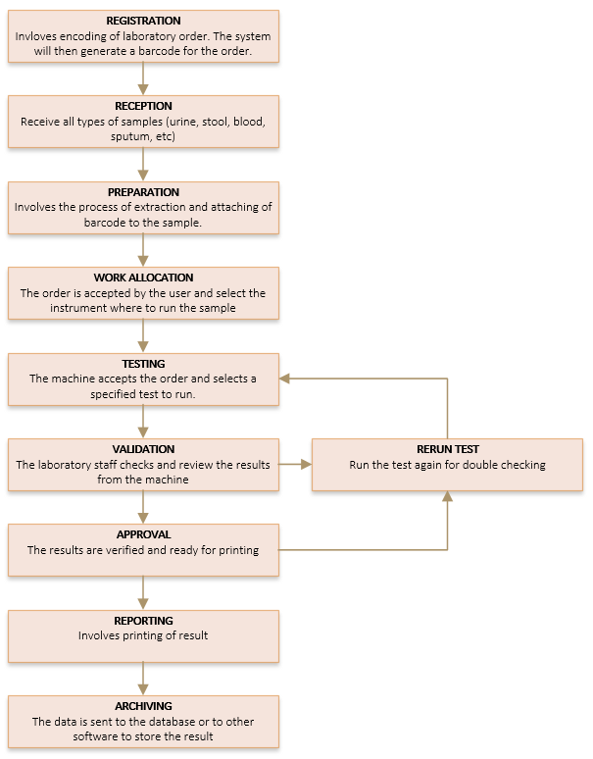

## User Access Levels

The LIS is used by laboratory workers and authorized users to add and modify data. The system provides three main user levels namely Medical Technologist, Encoder, and the System Administrator. Each user level corresponds to a specific task, thus, the low level users can access only a limited set of information, whereas the highest level users can access the most sensitive data on the system.

# Getting Started

## Logging on to the system



Double click the TCM Laboratory Information System with the logo as shown above to open the application.

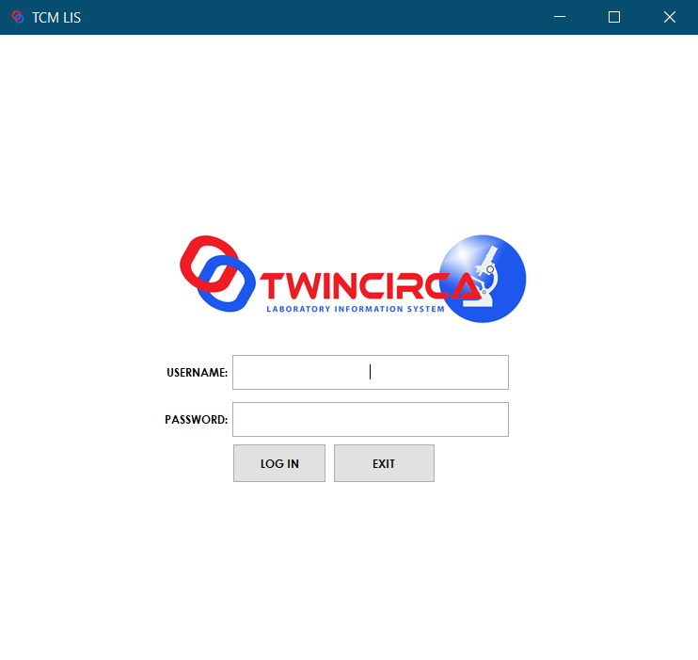

Enter username and password to log in and access the system.

## User account management

To login and access the system, please refer to the login section of the user manual for more details. Only administrators can add and modify user accounts (The default username and password is admin).

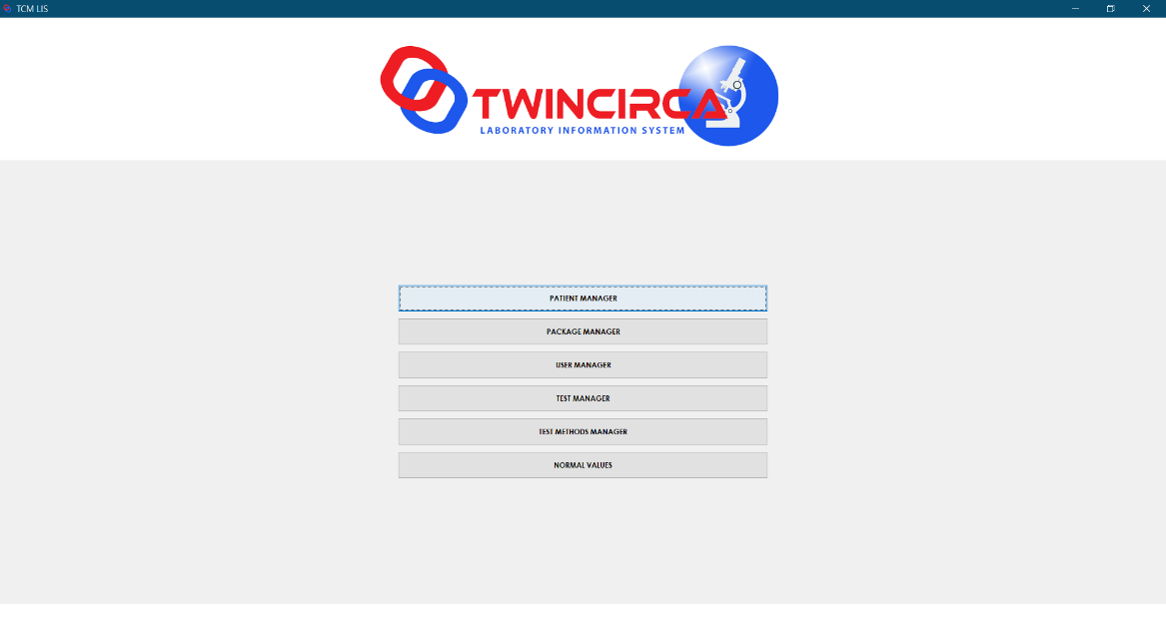

Click the “User Manager” button to open the form.

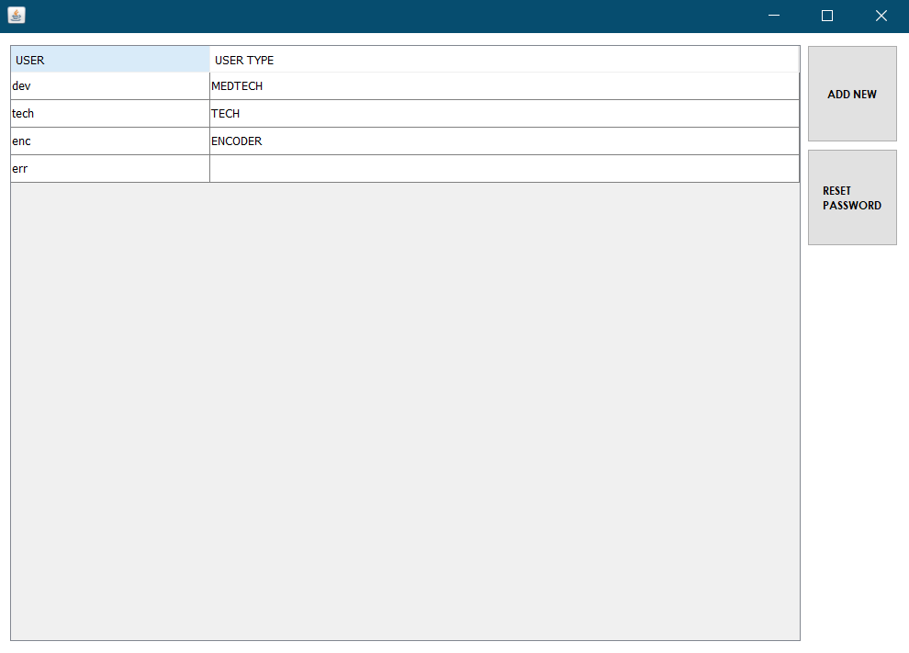

Click the “Add” button to add new system user.

­­

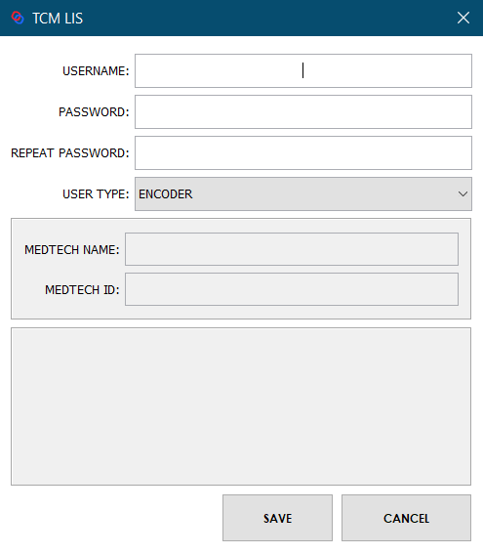

Input valid user information and choose the user type for the new system user. Click the “Save” button to save the information.

## Exit the system

To close the application, click the close button in the top-right corner of the window.

# Using the system

## Administrator

### Main menu

To login and access the system, please refer to the logging on section of the user manual for more details.



The main module for administrator include Patient Manager, Package Manager, User Manager, Test Manager, Test Methods Manager, and the Normal Values Manager.

### Patient Manager

This form allows the user to add, edit, and select patient information to be used in a certain laboratory order.

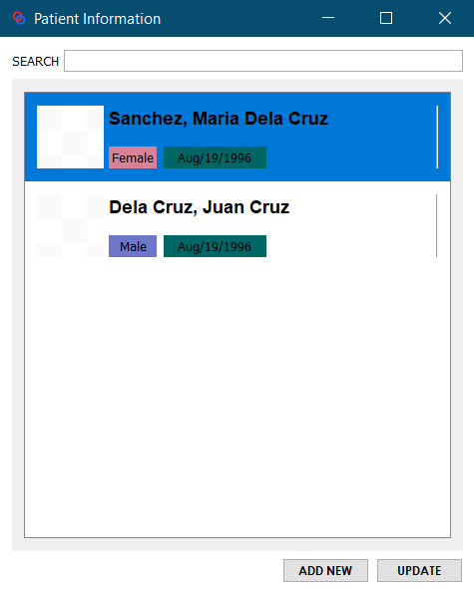

To access the patient manager form, click the “Patient Manager” button from the main menu. Click the “Add New” button to add patient.

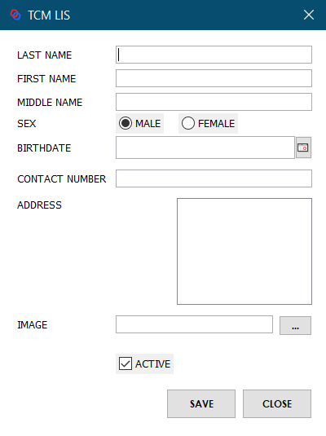

Input valid patient information and click the “Save” button to save the data.

### Package Manager

This form allows the user to manage and set tests on a specific machine used in the laboratory.

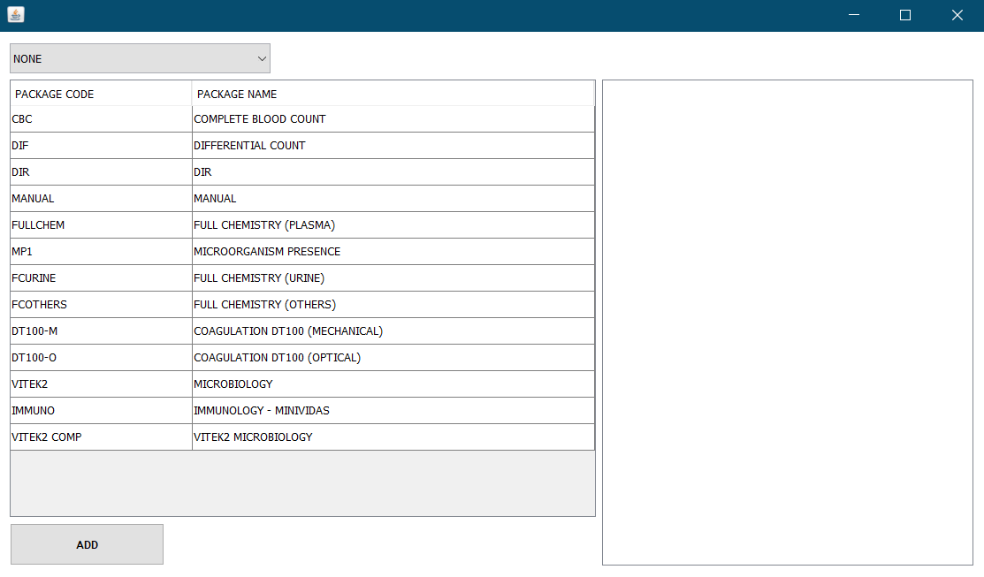

To access the package manager form, click the “Package Manager” button from the main menu. Click the “Add” button to add new package.

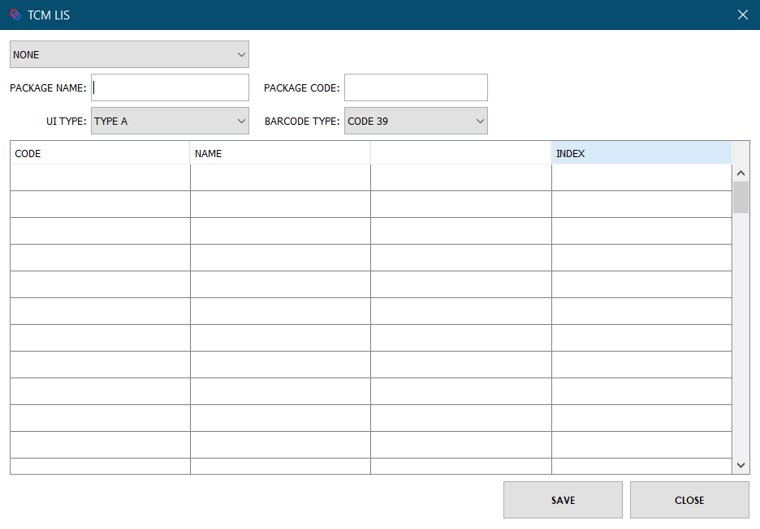

Fill in valid information and click the “Save” button to save the data.

### User Manager

This form allows the user to add, edit, and modify active status and user role of each system users of the laboratory information system. To access the user manager form, click the “User Manager” button. Please refer to the user account management section of the user manual for more details.

### Test Manager

This module allows the user to add, edit and view test packages that run on specific machines in the laboratory.

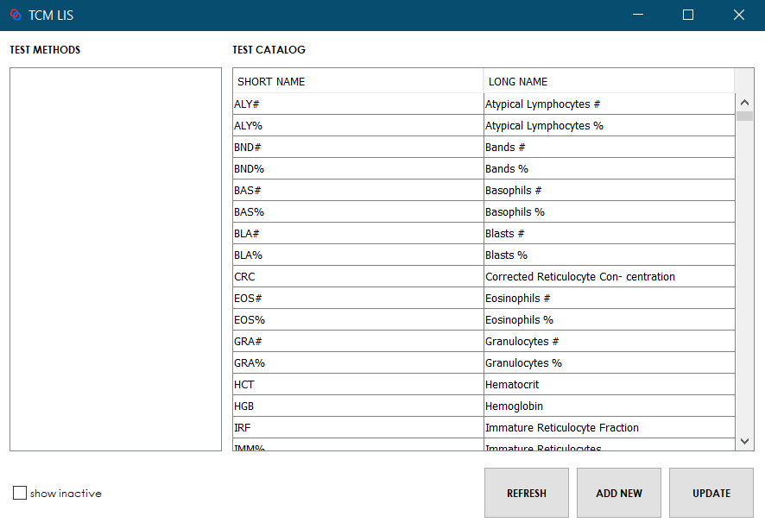

To access the test manager form, click the “Test Manager” button form the main menu. Click the “Add New” button to add new test.

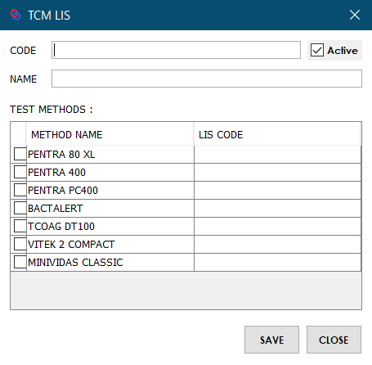

Input valid information and click the “Save” button to save the data.

### Test Methods Manager

This form allows the user to add, edit and view the machines used in the laboratory.

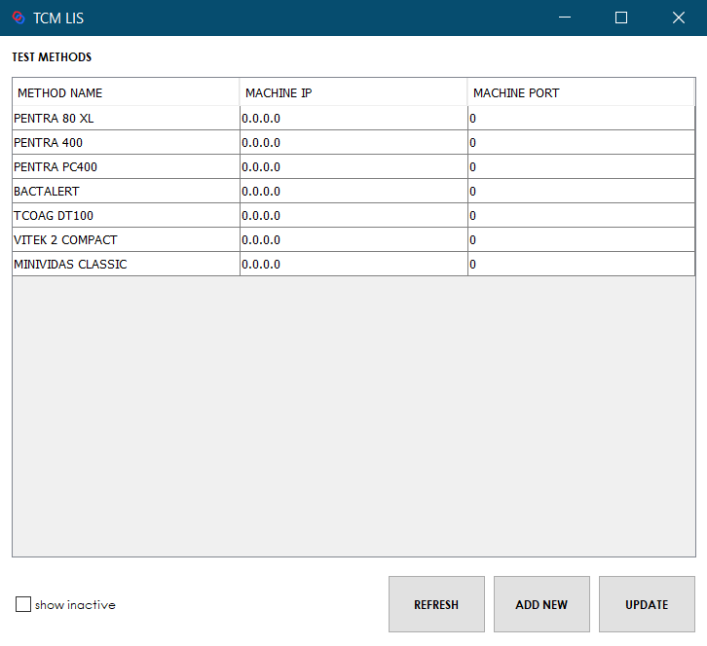

To access the test methods manager form, click the “Test Methods Manager” button from the main menu. Click the “Add New” button to add new test method.

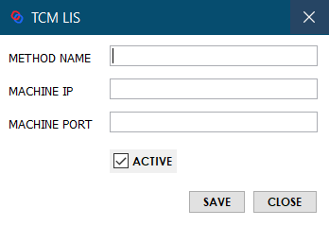

Input valid information and click the “Save” button to save the data.

### Normal Values Manager

This form allows the user to manage and set normal values on each tests run by the machines.

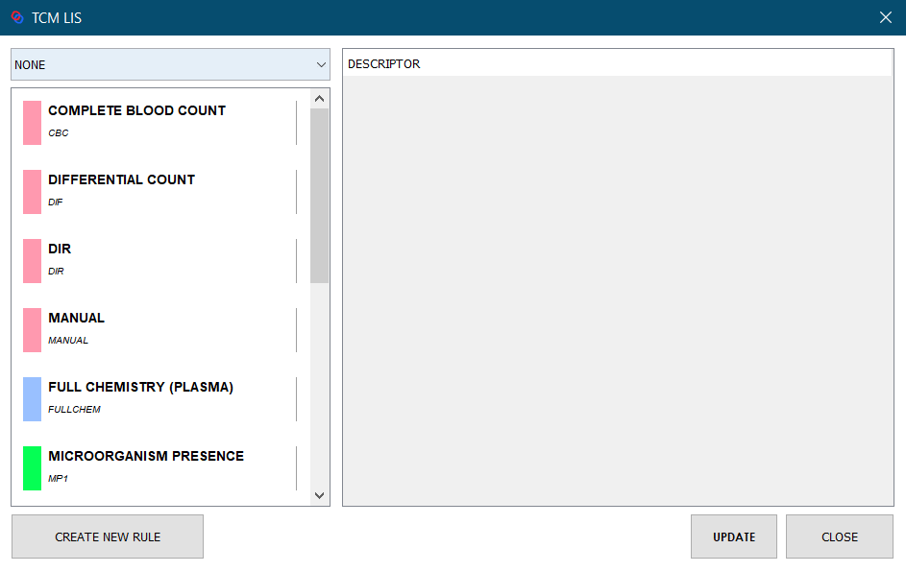

To access the normal values manager form, click the “Normal Values” button from the main menu. Click the “Create New Rule” button to set new normal value on a specific test.

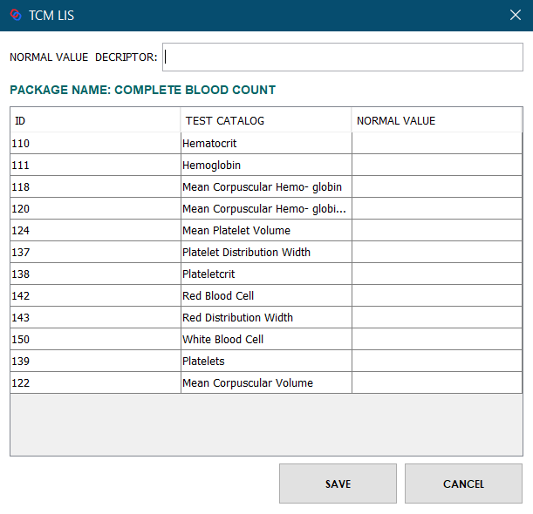

Input valid information and click the save button to save the data.

### Turnaround Time

This form displays the amount of time taken to complete a certain laboratory process, tests, or requests in the laboratory. This also provides statistical data based on laboratory operation and performance.

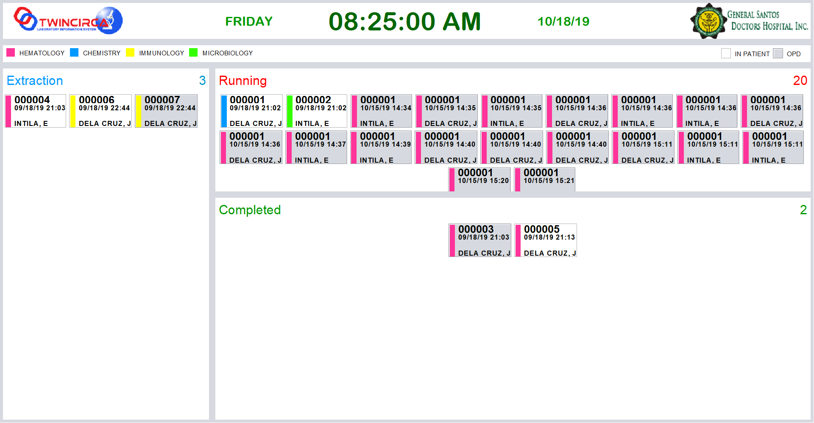

This form displays the current laboratory orders accepted by the laboratory worker that are categorized based on status i.e. pending, running, and completed phases of testing.

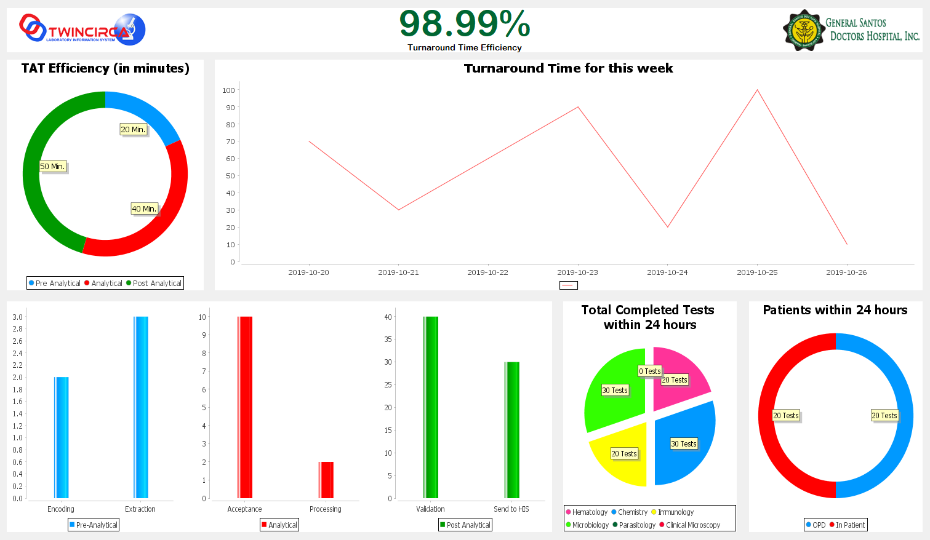

This form displays statistical data based on total tests run within 24 hours. This includes tests run per phases of laboratory, patient classification, tests on different laboratory section, and graph to show laboratory efficiency through turnaround time.

## For Encoders

### Main menu

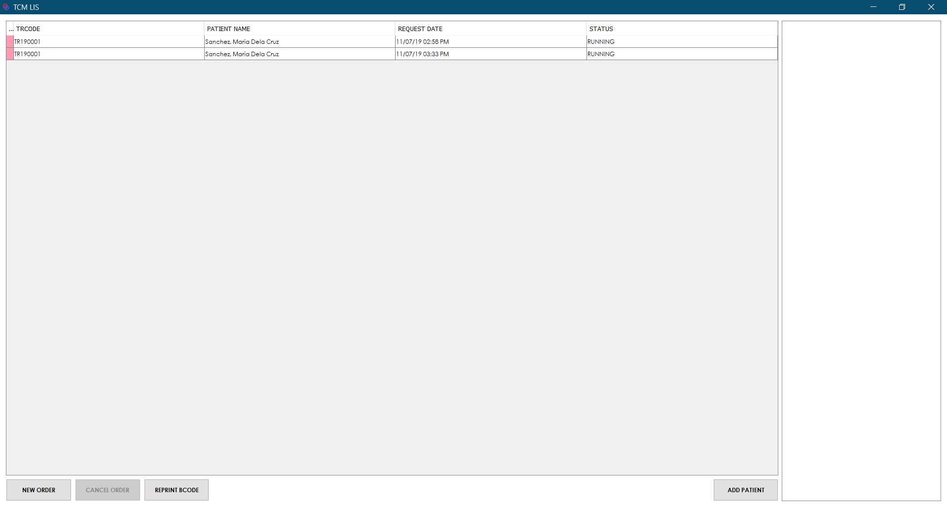

To login and access the system, please refer to the logging on section of the user manual for more details. To add new laboratory order, click the “New Order” button to open the form.

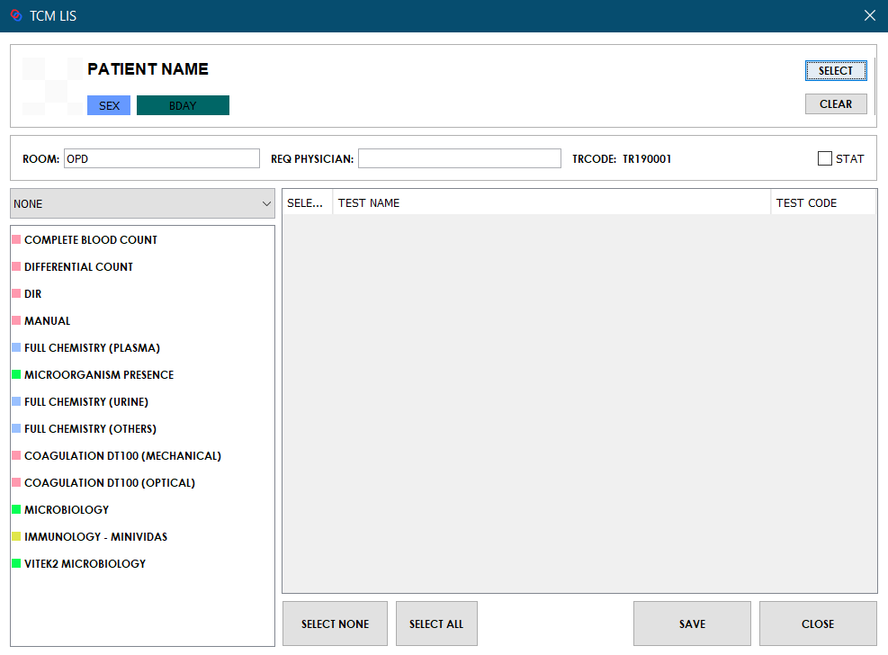

The module for adding new orders contains the patient information, room and physician information and tests to perform.

*Add new Laboratory Order*

Click the “Select” button to choose a patient. Use the search bar to filter results from the list. Select a patient from the list and click the “Select” button. Fill in the information for the room and requested physician. Then select the appropriate test package for the order. Use the drop-down to filter results from the list. Check the tests to perform form the table. To save the data, click the “Save” button.

The encoded laboratory order will be shown on the table. After saving the laboratory order, the system will automatically generate a barcode to the connected barcode printer. In case the barcode does not generate automatically, the user can select the laboratory order form the table and click the “Reprint” barcode button to generate the barcode. For cancelling the order, click the “Cancel” button to discontinue.

### Barcoding

*Placement of barcode label*



Fig. Sample with the attached barcode label

*Note: Avoid the barcode label to get wet, scratched or torn. The instrument barcode reader will not recognize it.*

*Placement of sample in the tray*

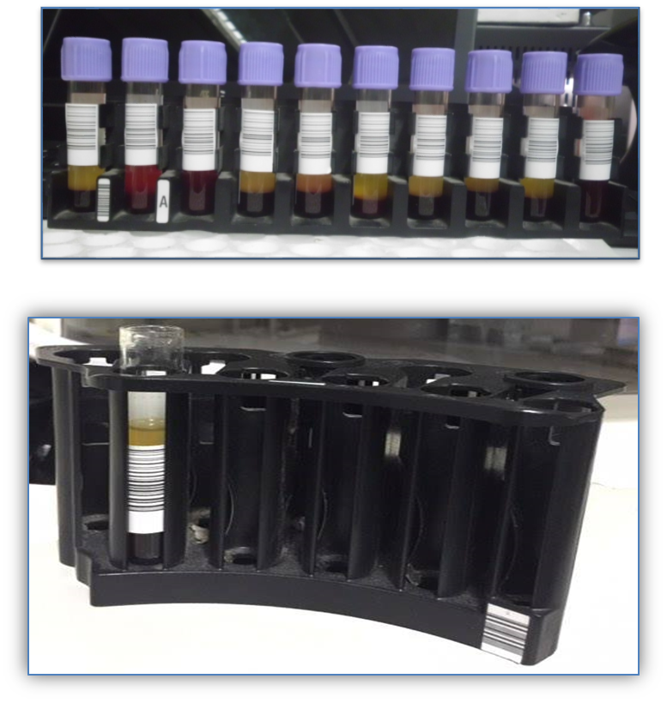

Fig. ABX Pentra400 and PC400 sample tray

*Note: Barcode label must be visible when loading sample in tray as shown in the figures above. Improper placement of sample may lead to the instrument not to recognize the barcode label.*

## For Medical Technologists

### Main menu

This form allows the user to accept pending laboratory orders, send the request to the machine, view order status and send the generated results from the machine back to the system.

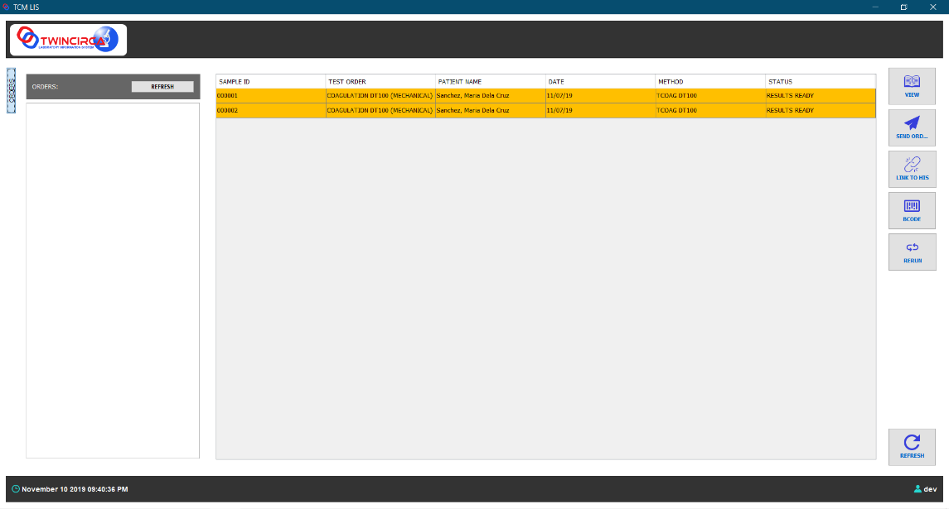

To login and access the system, please refer to the logging on section of the user manual for more details



This section of the main menu displays the pending orders sent from the reception section of the laboratory.



This section of the main menu displays the accepted laboratory orders with their corresponding status (i.e. Pending, Running, Results Ready).



The footer section of the main menu displays the current date and time and the logged in user of the system.



This button opens the form with results of a selected laboratory order from the table list.



This button sends the laboratory order to the machine.



This button sends the result of the selected laboratory order to the laboratory’s hospital information systems.

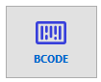

This button prints the barcode label of the selected laboratory order from the table.

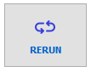

This button is intended for running again the tests of the selected laboratory order on the machine.

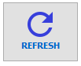

This button refreshes the list of laboratory orders in the table.

### Viewing the results

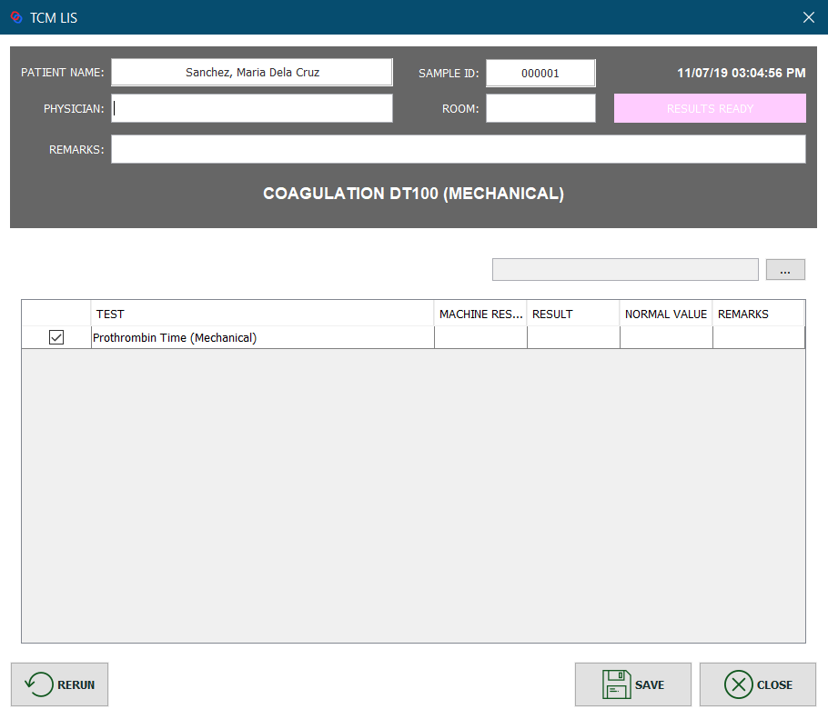

To view the results, click the “View” button from the main menu to open the form.

### Rerun the test

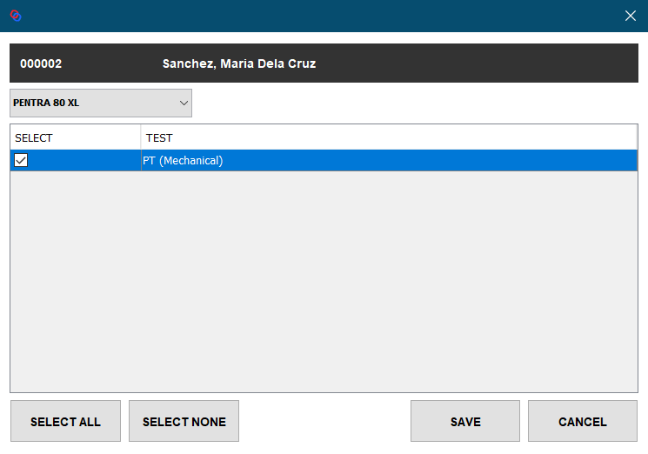

To rerun the test for double checking, select the result from the main menu and click the “Rerun” button. Select from the list of tests and click the “Save” button to proceed to the rerun of the laboratory order.

# Troubleshooting

## Software Troubleshooting

*Failed to open the application*

Check if the network cable is connected to the PC.

If the above recommendation were performed but problem still persist, please contact the technician of the company.

*Failed to login to the system*

Make sure to enter correct username and password.

If the above recommendation were performed but problem still persist, please contact the technician of the company.

*Failed to print the barcode label*

Check if the barcode printer is on.

Check if the barcode printer is connected to computer.

If the above recommendation were performed but problem still persist, please contact the technician of the company.

*Instrument unable to recognize barcode label*

Check if the barcode label is properly placed and is not damaged (*refer to proper placement of barcode label*).

Check if the sample tube is properly placed in the sample rack (*refer to proper placement of sample in sample tray*).

If the above recommendation were performed but problem still persist, please contact the technician of the company.

## Network Troubleshooting

*Can’t send test request and receive result from the instrument*

Check if computer is connected to the network.

Check if the network cable is connected to the computer.

If the above recommendation were performed but problem still persist, please contact the technician of the company.

## Important Notes

User intervention is a crucial part of Laboratory Information System. Improper handling and understanding of the system may lead to delay of operations and worst is faulty result. Below is the list of information the user must consider when using the system:

* **Attachment of barcode label** – make sure to attach the barcode label in the correct sample. Incorrect attachment will lead to faulty result. Also follow proper placement of barcode label in sample tube. (refer to placement of barcode label)
* **Placement of tube to the sample tray** – Barcode label must be facing out (visible) to the barcode reader in order for the instrument to recognize the sample. (Refer to placement of sample in tray).
* **Proper encoding of test request** – make sure to encode the requested test correctly to avoid delay of operation and repetition of process.
* **Sending of test to the machine** – be sure to select the machine that is currently active (Ex. in chemistry section, two units is being used; P400 and PC400) Select the machine that is currently in use.